**Pizza Sales MS-SQL Server Queries Doc**

**Entire Data View:**

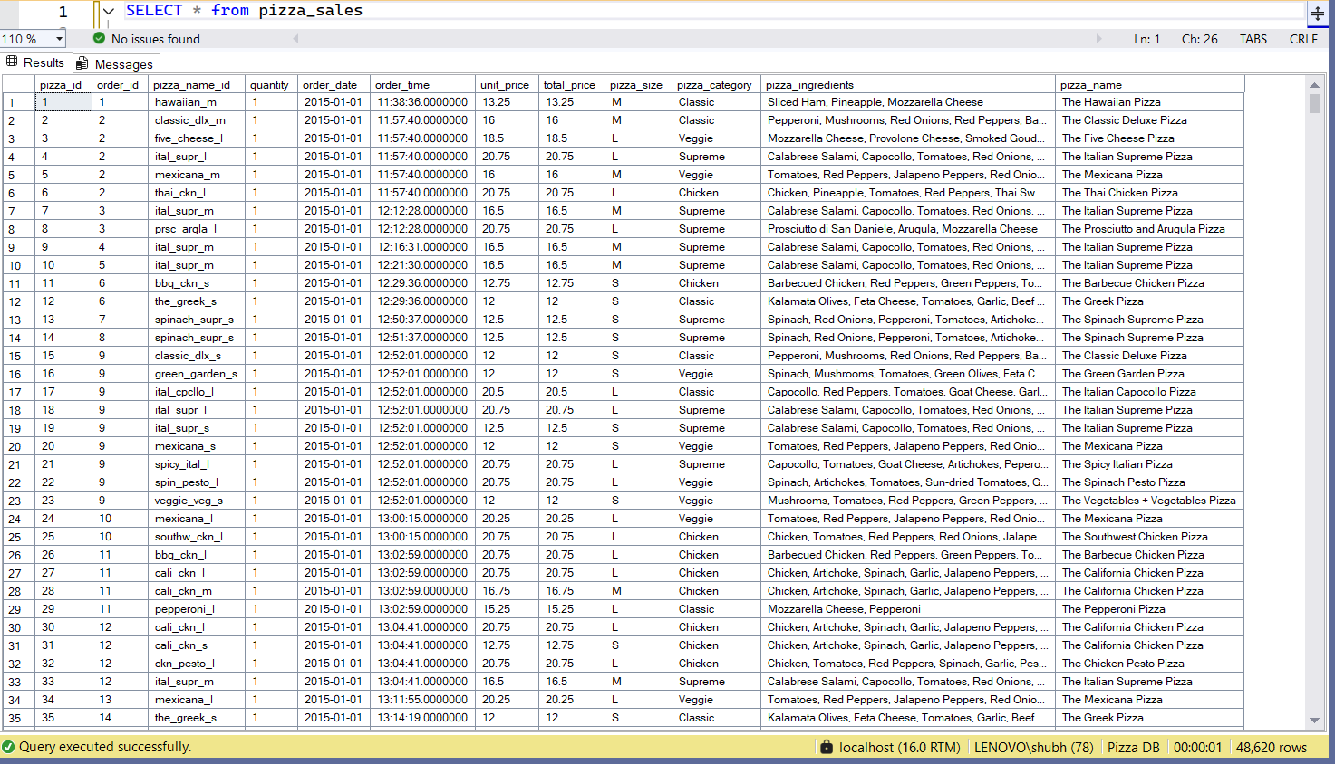

1. Total Revenue:

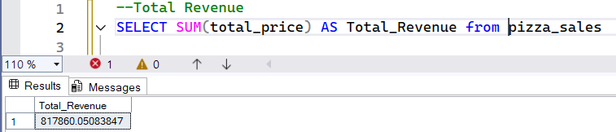

1. Average Order Value:

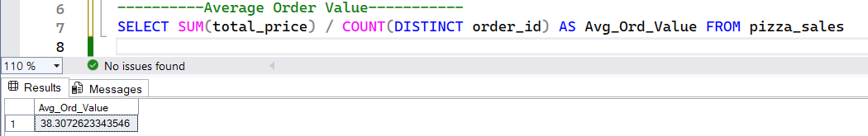

1. Total Pizza’s Sold:

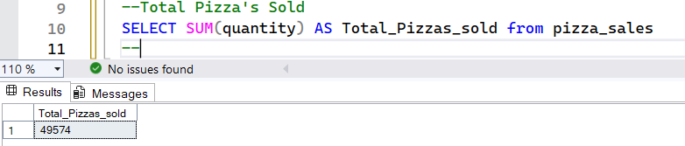

1. Total Orders’s places:

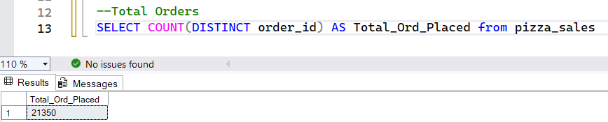

1. Average Pizza’s per order:

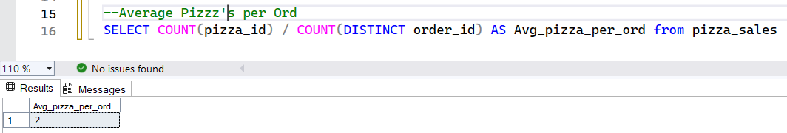

1. Week day wise Total Orders:

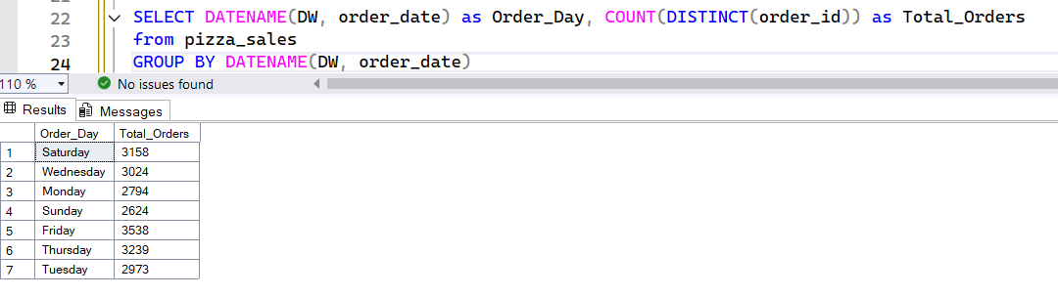

1. Month wise Total Orders:

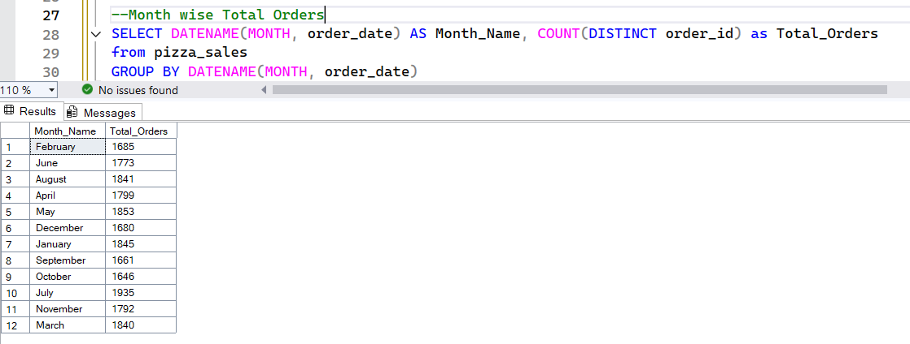

1. % of Sales by Pizza Category

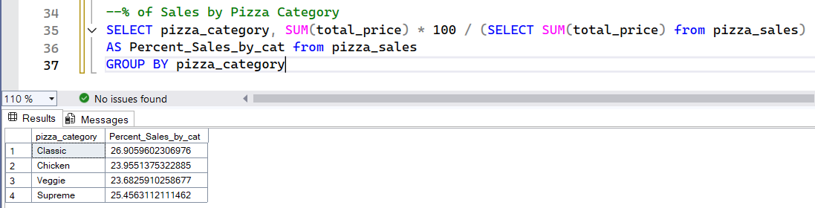

1. % of Sales by Pizza Size

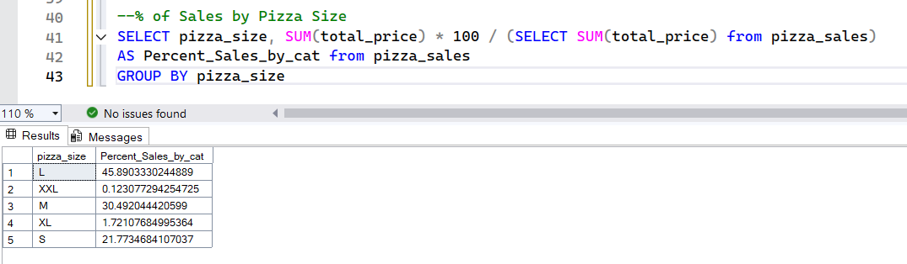

1. Top 5 best sellers by Revenue, Total Quantity and Total Orders

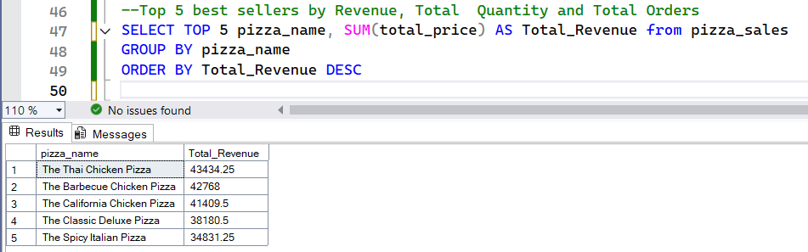

1. Bottom 5 Best Sellers by Revenue, Total Quantity and Orders

